Robert F. Hempstead
Town of Cairo Highway Superintendent
755 Route 145
Cairo, NY 12413
518-622-9515
518-622-3185 Fax
518-965-1266 Cell
highwaysuper@townofcairo.com

Highway Report
August 16, 2017

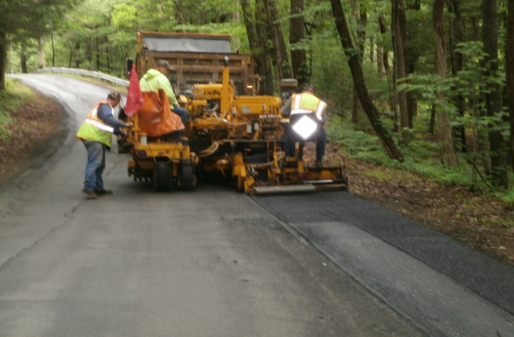

- Hot asphalt lee boy/machine paving for repairs and in preparation for resurfacing: 1144 tons to date
- Servicing and repairing spring/summer equipment: paver, rollers, mowers, etc.
- Sign repair and replacement ongoing
- Both flail mowers and boom flail mower have been out road side mowing. Currently on 5th cut of the season
- Road side drainage (ditching and culvert installations)
- Hauling stone in for surface treatment and culvert installations
- Shoulder clean up with gradall
- Multiple driveway requests
- Mechanics have been visiting multiple highway/commercial truck sale sites inspecting trucks/snow and ice equipment for possible purchase of new and used.
- Community service worker through probation
- Met with insurance agent regarding notice of claim (SR32 and Silver Spur)
- Repaired and installed Hometown Hero Banners after vandalism
- Attended equipment show
- Shared services with Town of Hunter: sent trucks and drivers to assist with oil and stone resurfacing
- Met with multiple paving companies assessing roads
- Onsite audit with Perma
- Crews are out clearing tall grasses, brush and weeds around guide rail and traffic signs
- Assessing and repairing current snow and ice equipment
- Held ongoing safety training classes
- We lost two full time/DOT class A licensed employees to higher paying jobs.

