Robert F. Hempstead
Town of Cairo Highway Superintendent
755 Route 145
Cairo, NY 12413
518-622-9515
518-622-3185 Fax
518-965-1266 Cell
highwaysuper@townofcairo.com

Highway Report
June 5, 2017
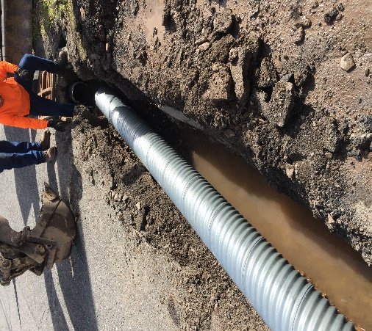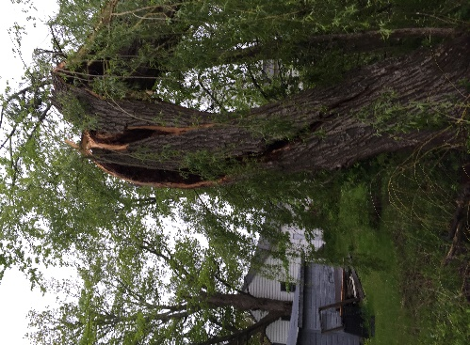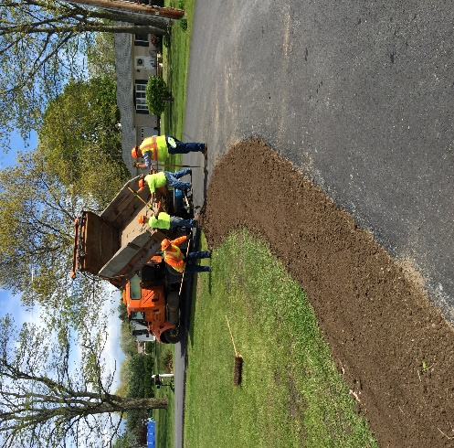

- Both cold and hot asphalt patching
- Servicing spring/summer equipment: rollers, mowers, etc.
- Sign repair and replacement ongoing
- Roadside trash pick up: furniture, mattresses (Main Street, South Cairo, Round Top, etc.)
- Responded/cleaned up storm damage from high winds
- Rolled the Cairo Elementary School soccer fields.
Used road side mower purchased from Greene County Highway Department delivered
- Mechanics attended air brake class.
- Highway deputy attended Cornell’s Local Roads program Road Safety 365
- Communicating with comptroller’s office
- Assisted with the installation of American flags
- Shoulder work in the south Cairo development: installation of top soil to back up newly paved pavement
- Pricing the refurbishing Unit #5 (truck/snow and ice equipment)
- Provided services and equipment for the parks, buildings and grounds department (mulch for the updating of playground area, clean up of down trees at the annex, etc.)
- Both flail mowers have been out road side mowing. First round 90% complete
- Both broom and vacuum broom and water tank have been out sweeping
- Evaluating roads for this year’s surface treatment program
- Purchased six man International crew cab dump
- Gradall out doing drainage work, cleaning out residuals from cul-de-sacs, shoulder work
- Pricing new tandem axle trucks with snow and ice equipment, viewed Greene County and neighboring town’s equipment with highway liaison
- Pricing a used truck to replace osh kosh truck with snow and ice equipment that was totaled out this past season.
- Representative from Freightliner brought a new cab and chassis to view
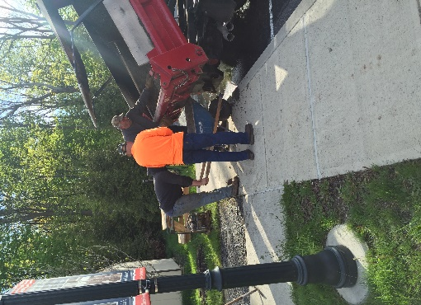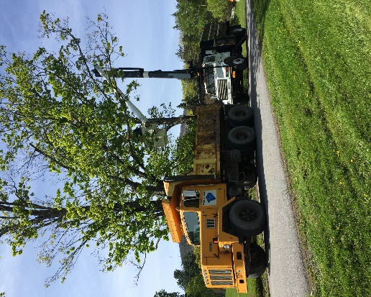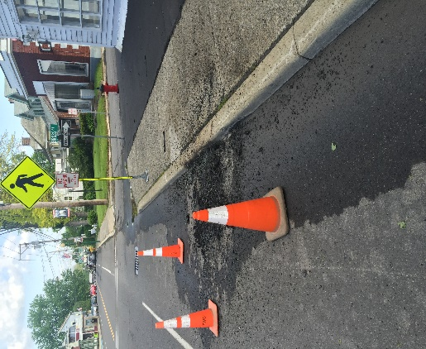
- Mowed County roads 84, 85, and 23b (Main Street) for the parade route and holiday weekend.
- Temporary catch basin and culver replacement on Railroad Avenue.
- Police are on an ongoing tractor trailer parking problem on Plattekill Road
- Sidewalk repair at library
- Cut trees with county at Winterclove Resort
- Repaired roadway Main Street Cairo from downed electrical wire damage

