Robert F. Hempstead
Town of Cairo Highway Superintendent
755 Route 145
Cairo, NY 12413
518-622-9515
518-622-3185 Fax
518-965-1266 Cell
highwaysuper@townofcairo.com

Highway Report
April 3, 2017
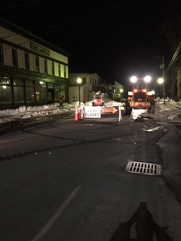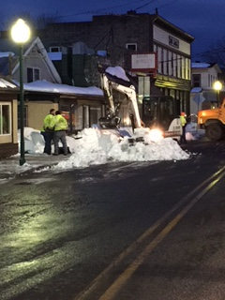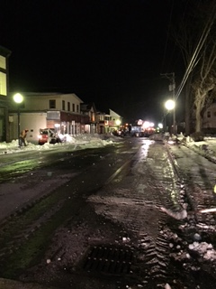
- Multiple snow/ice events (Stella)
- Removed snow from Main Street, Mountain Avenue and Hannaford sidewalks.
- Removed large snow piles from intersections
- Mailbox replacement/repair
- Road sweeping commenced with rental broom
- Town vacuum broom being repaired: radiator replacement and hydraulic cylinder repair
- Storm Stella equipment repairs:
  - Front differential #10
  - Front axle #4
  - Gear shifter #13
  - Hub, wheels and tires #3
  - Sander motor replaced #2
  - Wiper transmission ordered #28
  - Wheels and tires on L9000
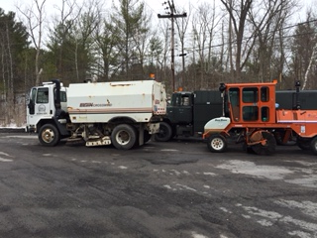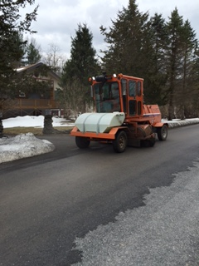

- Cold patching potholes as weather permits
- #18 has been declared totaled by the insurance company
- Repairs on winter equipment continue
- Submitted storm Stella preliminary damage assessment form to the county
- Servicing spring/summer equipment
- Sign repair and replacement
- Highway building repairs/renovations
- Roadside trash pick up
- Storm damage: tree and brush clean up
- As sweeping continues, roads will be evaluated for 2017 repairs/surface treatments
- Removed illegally parked vehicles before storm stella with the help of Cairo Police Department

