Robert F. Hempstead
Town of Cairo Highway Superintendent
755 Route 145
Cairo, NY 12413
518-622-9515
518-622-3185 Fax
518-965-1266 Cell
highwaysuper@townofcairo.com

Highway Report
January 2, 2017
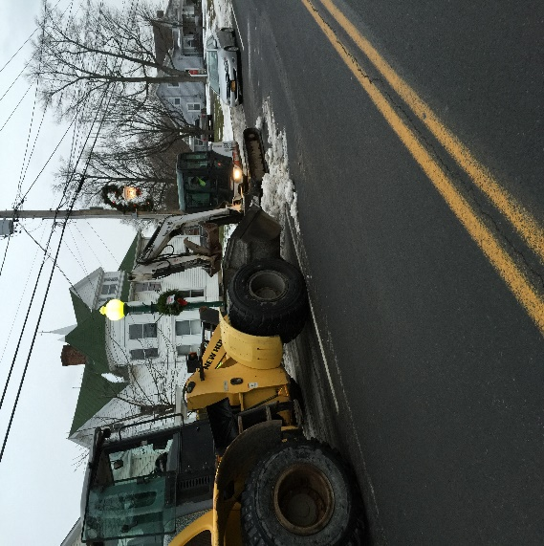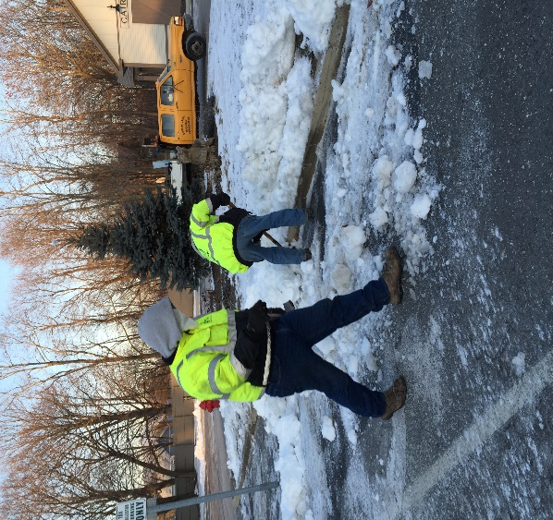

Highway tasks performed:

- Multiple snow events
- Drainage/ditching: replacing culverts
- Tree and brush cutting
- Road Sign replacement continues
- Preparing/repairing trucks for winter use
- Road side trash pickup: couches and chairs
- Cold patching potholes as weather permits
- New employees training on snow/ice equipment
- Mixing/hauling/stocking road salt and sand
- Installed gas heater in the mechanic’s work area
- Snow removal from Town Hall, Main Street, Purling, sidewalks
- Town of Maryland truck motor removed and installed in Unit #9
- Number 3 went off road during a snow event and struck tree damaging truck and stainless steel spreader
- Installed/repair radios in loader, #18 and the second Town of Maryland truck
- Employee in service on workplace violence at the library
- Another highway employee resigned from the town to go to work for Greene County, which now totals 4 Cairo employees in 14 months
- We still have one full time employee on medical leave
- With current conditions, there is not enough personnel to man our snow equipment and we are presently advertising for additional part time/seasonal help. In the past parks, buildings, and grounds personnel were cross trained to man highway equipment
- Installed catch basin in South Cairo development to alleviate severe drainage problem

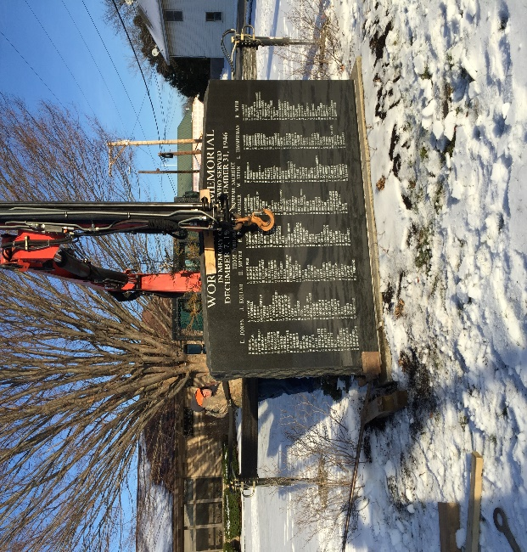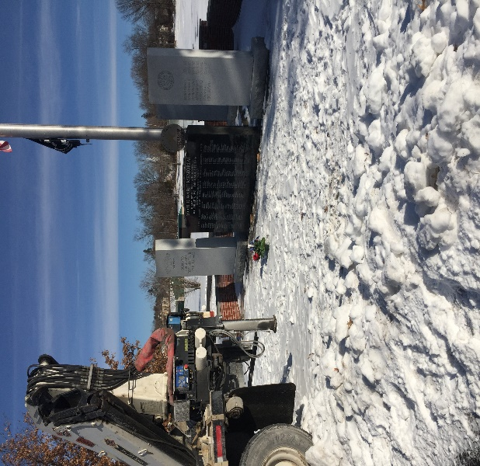

Park maintenance:
- Moved the WWII monument from Town Hall to the Veteran’s Circle in town park to facilitate electronic sign installation at town hall
- Installed hay in dog park area

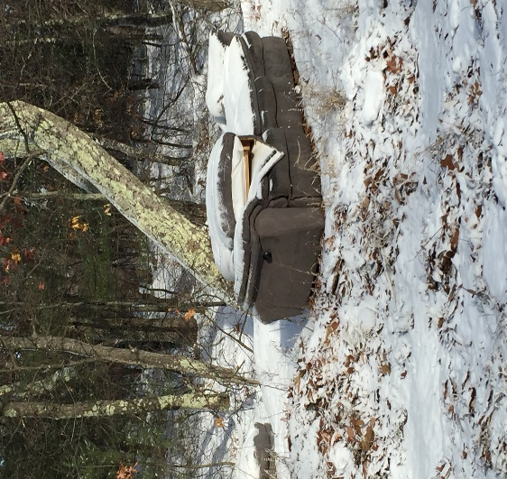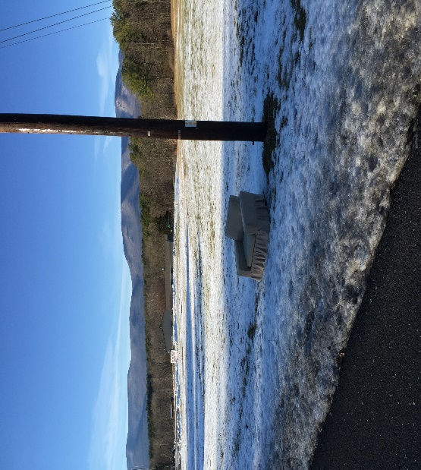

Miscellaneous
- Still pending: Crew cab truck with snow and ice equipment purchase with 2015 funds, skid steer with snow blower, regular cab truck with snow and ice equipment, one salt spreader for #10
- Still pending: repairs to salt building
- 2015 funds need to be reserved for Polly’s Rock Bridge. (Yellow flagged)
- Sent out RFPs for electrical work
- Serviced/repaired furnace at ambulance building
- Multiple library alarms
- HVAC repair by Trane
- Ambulance auctioned from Auctions International, winning bid $9,500.00, removed Cairo lettering and prepped for transport.
- Annex: excavated sewer line, received HVAC quotes
- Repaired light post at library

