Robert F. Hempstead
Town of Cairo Highway Superintendent
755 Route 145
Cairo, NY 12413
518-622-9515
518-622-3185 Fax
518-965-1266 Cell
highwaysuper@townofcairo.com

Highway Report
July 3, 2017

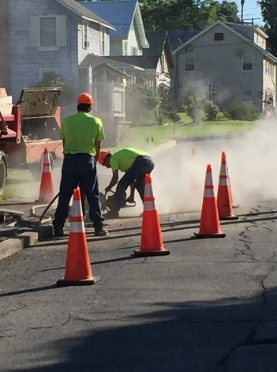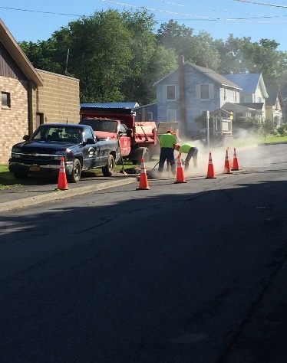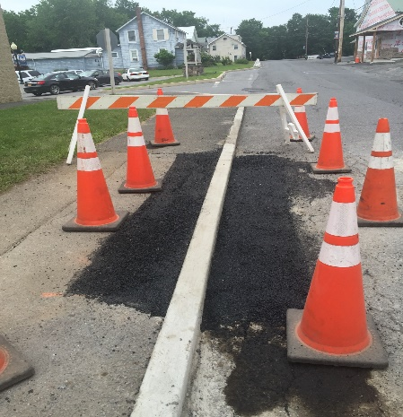

- Hot asphalt lee boy/machine paving in preparation for resurfacing
- Servicing spring/summer equipment: paver, rollers, mowers, etc.
- Sign repair and replacement ongoing
- Highway deputy attended OGS procurement training at Columbia Greene Community College
- Provided services and equipment for the parks, buildings and grounds department (Bucket truck, ladders, for use at annex building and street light repair. Repaired curb on Railroad Avenue)
- Provided aggregates for multiple parks, buildings and grounds projects
- Both flail mowers have been out road side mowing. Currently on 3rd cut of the season
- Evaluating roads for this year’s surface treatment program
- Met with insurance agent to evaluate current equipment inventory to reduce premiums
- Met with representative from Gorman Brothers for 2017 surface treatments
- Met with engineer regarding hydrology study for Bald Hill Road culvert replacement and Polly’s Rock bridge. ( Future bridge replacement and to mediate yellow flag from NYSDOT. Reduced road load from 20 tons to 18 tons.)
- Onsite visits to Town of Saugerties/Lexington highway departments to assess their recent tandem axle dump truck equipped with snow and ice equipment
- Trailered/repaired newly acquired Greene County Paramedic vehicle to be used by water department
- Rehabilitated newly purchased international 4700 crew cab dump
- Multiple storm events, reopened roads, cleaned up downed trees
- Culvert installation/drainage/ditching
- Hauling stone in for surface treatment
- Shoulder clean up with gradall

