Robert F. Hempstead, Highway Superintendent
Town of Cairo Highway
755 Route 145
Cairo, NY 12413
518-622-9515 Phone
518-965-1266 Cell
518-622-3185 Fax
highwaysuper@townofcairo.com

Highway Report

March 6, 2017

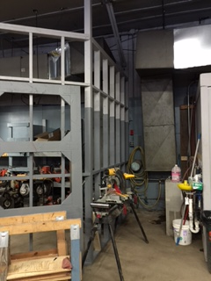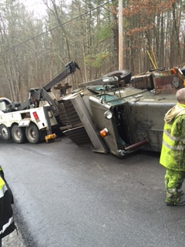

- Multiple snow/ice events
- Removed snow from Main Street and side walks
- Cold patching potholes after weather events
- Tree and limb clean up from multiple wind events
- As the snow subsides road side trash clean up (is picking up)
- Hauling/mixing/stock piling road salt and stone dust until vendor supply was depleted
- Sorting scrap metal to be marketed
- Highway building repairs/renovations
- Storm damage property repairs

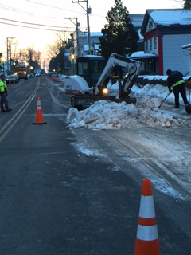

- Sign repair and replacement
- Removed lighted seasonal snowflake decorations from Main Street/Mountain Avenue/Purling
- Attended Greene County Highway Superintendent Association meeting
- Met with Gorman Brothers regarding 2017 resurfacing
- Held multiple safety training sessions for employees
- Salt purchased for the November Snow and Ice season to present totals 2127 tons. Stone dust (abrasives) hauled in and used for season to date totals 2650 tons. This does not include what was stocked and used from previous season.
- Mailbox replacement/repair
- Assessing roads for repairs/paving/resurfacing
- Ice problem Main Street sidewalk/curb line
- Problems with resident on Schmidt Drive, parking registered, unregistered vehicles and debris on town highway
- Snow plow #16 totaled during snow and ice event
- Gradall maintaining drainage structures
- Road sweeping will commence, weather permitting March 20, 2017 to include Town owned water tanker, vacuum sweeper and leased sweeper
- Mechanics continue to make repairs on snow/ice equipment.
- Servicing spring/summer equipment
- Procured road side mower (tractor) from Greene County Highway Department
- Signed and returned the annual shared services agreement with NYSDOT

