Robert F. Hempstead
Town of Cairo Highway Superintendent
755 Route 145
Cairo, NY 12413
518-622-9515
518-622-3185 Fax
518-965-1266 Cell
highwaysuper@townofcairo.com

Highway Report
May 8, 2017
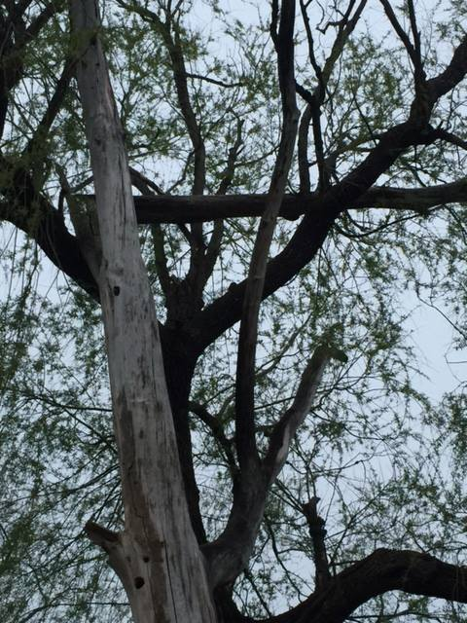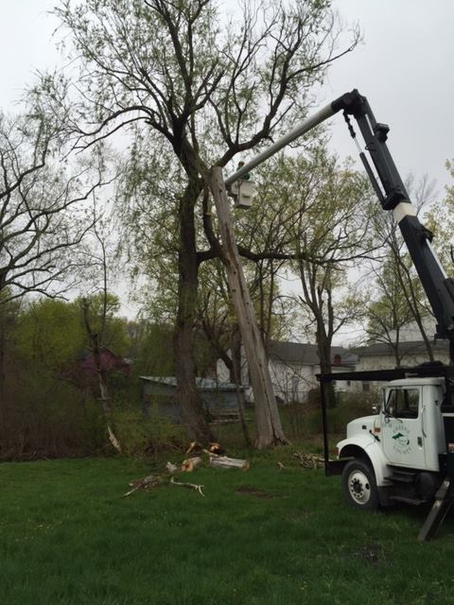
- Swept Main Street with Town highway sweeper
- Mailbox replacement/repair
- Road sweeping continues with rental broom/town highway vacuum sweeper
- Cold/hot patching potholes as weather permits
- Installed Hometown Hero banners on Main Street
- Servicing spring/summer equipment: rollers, mowers, etc.
- Sign repair and replacement ongoing
- Highway building repairs/renovations
- Roadside trash pick up
- As sweeping continues, roads will be evaluated for 2017 repairs/surface treatments
- Met with the state regarding storm Stella reimbursement
- Cutting trees on Sandy Plains, Scotch Rock
- Cut a dangerous tree which had broken off behind the annex
- Vacuum swept and patched potholes at the town park
- Vacuum swept Acra Community Center and Town Hall parking lots
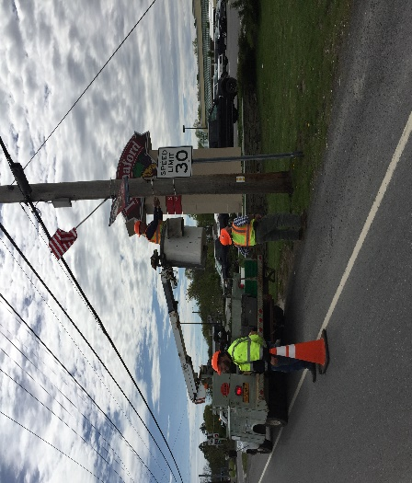

- Whole crew attended chainsaw safety, chipper safety, distracted driving, and electrical hazard safety program
- Yard waste program is still in effect. Anyone that would like to bring yard waste to the highway department, please stop in the office and sign in between the hours of 8-3 Monday through Thursday.
- Highway will be rolling the Cairo Elementary School soccer fields.
- Half the crew attended and received their flagger certification
- Purchased used road side mower from Greene County Highway Department
- Winter storm damage cleanup continues

